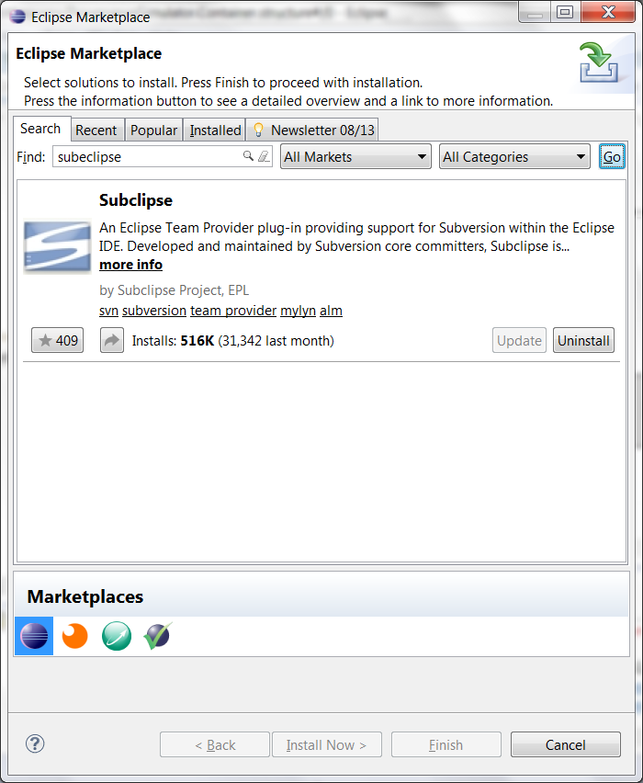
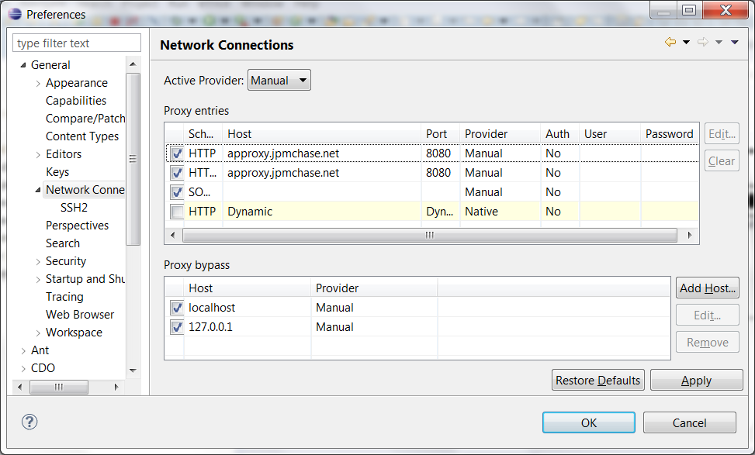
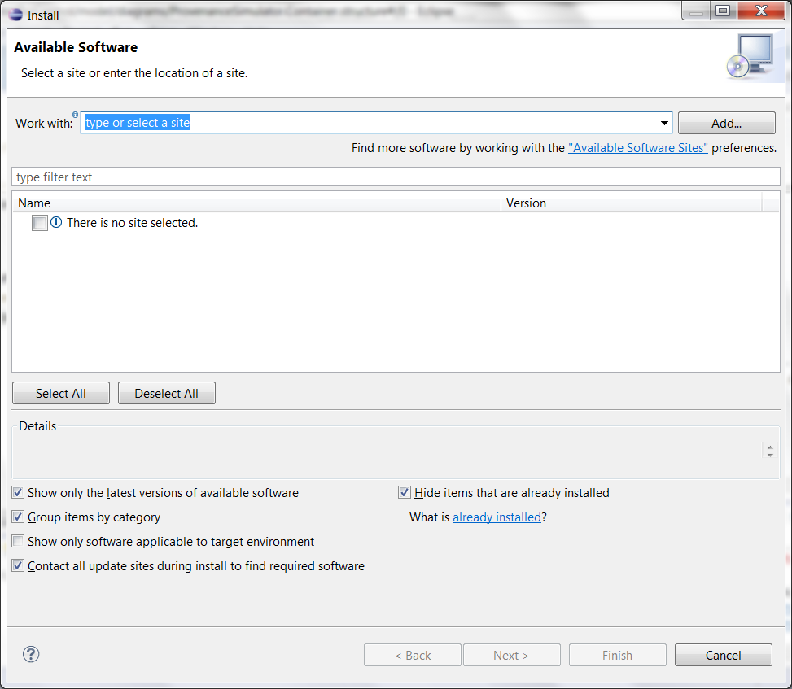
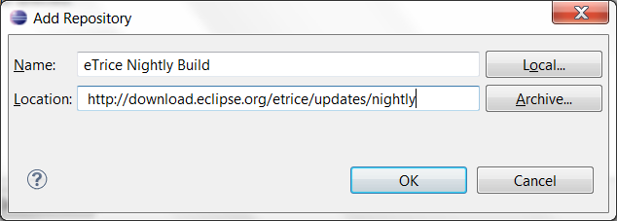
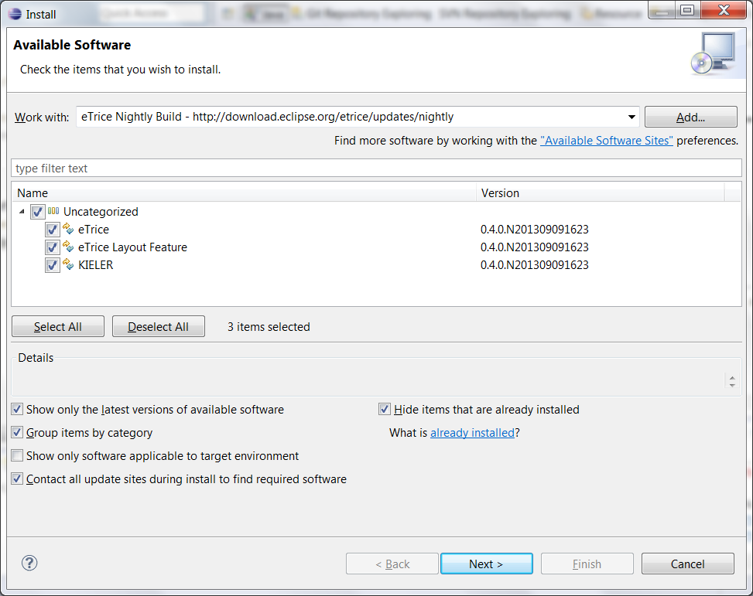
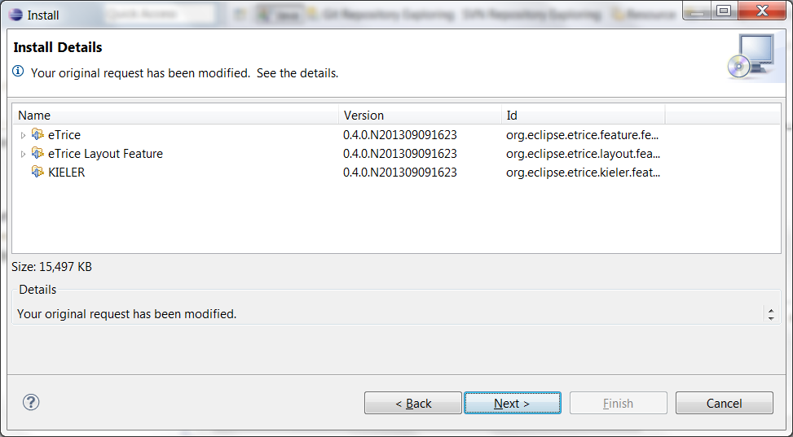
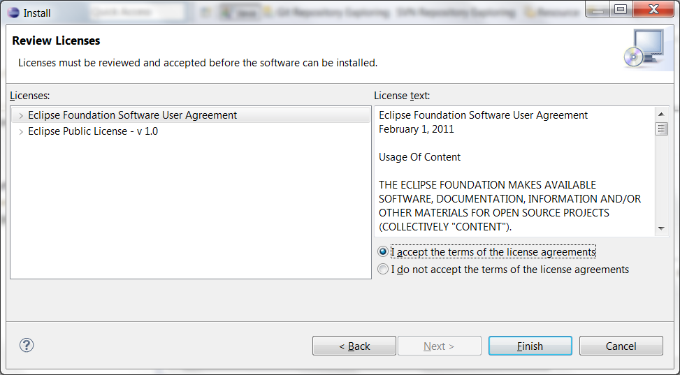
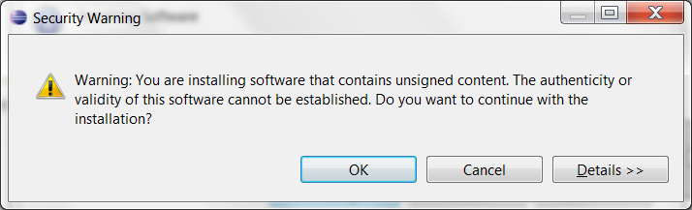
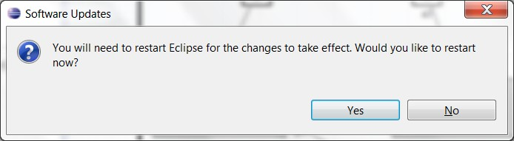
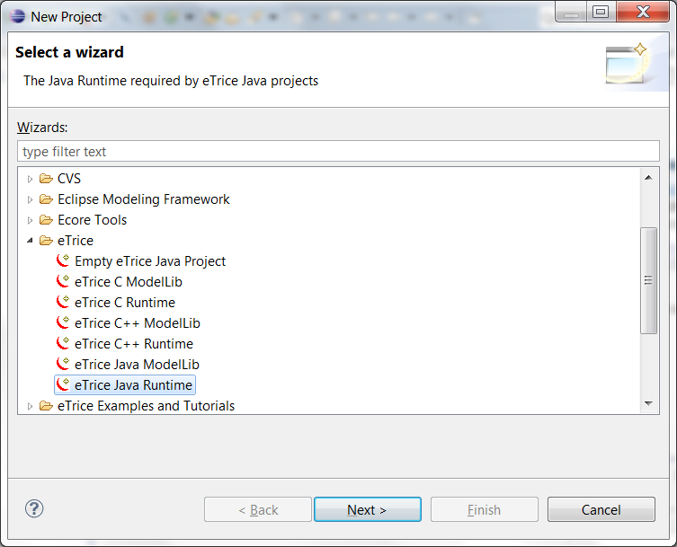
eTrice Installation instructions
- Latest version of eTrice requires Kepler version of eclipse. Recommended installation of Kepler release is: Eclipse Modeling tools
- Ensure that you have 64-bit version of java installed.
- In order to ensure 64-bit version of java is used by Eclipse, add following 2 lines to the eclipse.ini file in the root folder of the eclipse installation.
-vm
<location of 64-bit javaw.exe>
e.g.
-vm
C:/FAST/JDK64/1.6.0.31/bin/javaw.exe
- Install latest version of eTrice from the nightly build update site: http://download.eclipse.org/etrice/updates/nightly
  - Go to Help→Install New Software…
  - Click on “Add..” to add the eTrice nightly build update site as shown below:
  - Select all the components available from the update site and click “Next” as shown below:
  - Click next on the following screen:
  - Accept terms of license agreement and click finish:
  - Click “OK” on the security warning dialog box.
  - Once eTrice installation is completed it will prompt to restart eclipse. Click “Yes”
  - eTrice plug-in is now installed. Before you can start any eTrice modeling projects, you need to create following 2 projects in the workspace. Ensure you install them in order.
    - eTrice Java Runtime
    - eTrice Java ModelLlib
    - Click on File→New→Project and select eTrice→eTrice Java Runtime to create “eTrice Java Runtime” project as shown below:
    - Follow same steps to create “eTrice Java ModelLib” project.
    - Now you are ready to create and play with any eTrice Examples.
- You will need to install trace2uml tool in order to visualize sequence charts produced by eTrice.
  - You will need local admin rights to install the tool.
  - Once tool is installed, you can view sequence diagrams generated by eTrice run by double clicking the .seq files from within eclipse.

eTrice Update Instructions
(Assumes eTrice is already installed and nightly update site for eTrice is in the list of update site in Eclipse)
- From your Eclipse click on “Help→Check for Updates”. If you see any available eTrice updates, install them.
- After eTrice is updated remember to delete both “org.eclipse.etrice.runtime.java” and “org.eclipse.etrice.modelLib.java” from the current workspace and re-create them by following instruction from the instructions above.

